UFC Fighters

One of the stories that we are trying to tell is where most of the fighters come from. An example of the visualization is provided in the figure below.

Figure 1.1 – Example of Countries with Most Fighters.

If a user is to selects a country on the map. They will be able to see the top fighters of that country. Example below is a visual example of overlay label that can be used to list fighter name.

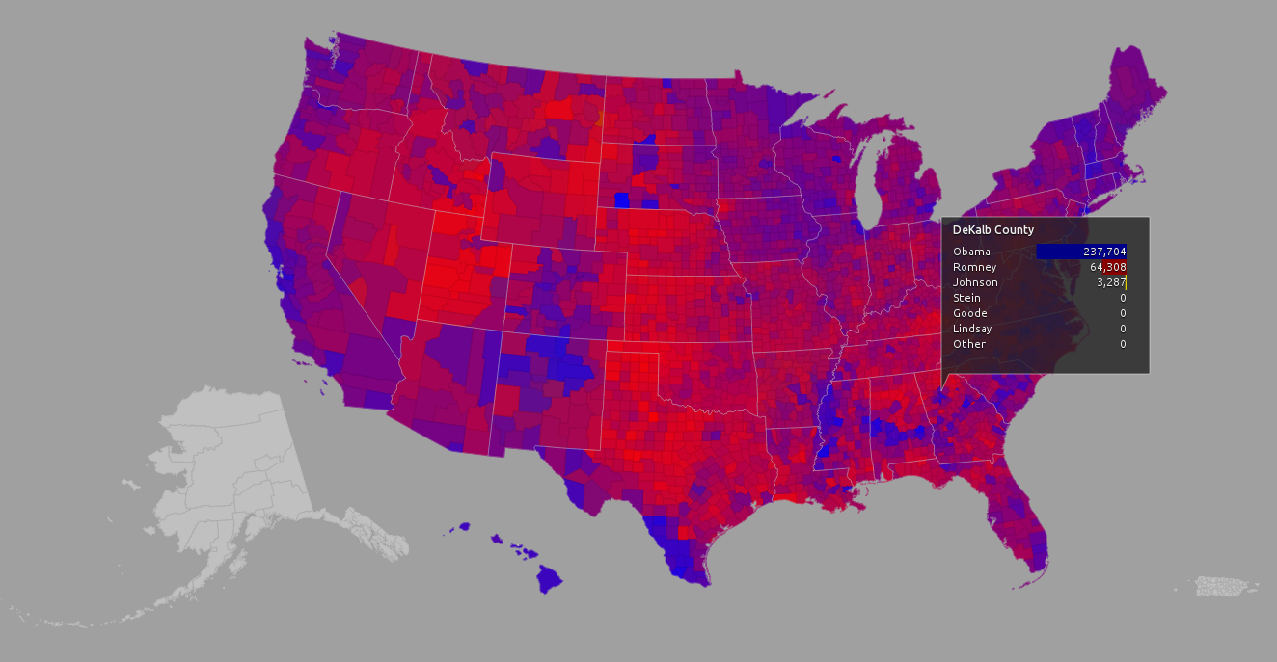

Figure 1.2 – Example of a U.S. Map Used to Display Fighter Name

The third visualization for this project will be a comparison of different statistics between different countries. These stats can be the number of winning fighters in a country, the number of fighters within those countries within the time frame of 2000 to current.

Figure 1.3 – A Line Graph That Will Show Visualization Between Countries.

The Data Sources for this project will come from the following sources.

Kaggle – UFC-Fight historical data from 1993 to 2019

<https://www.kaggle.com/rajeevw/ufcdata>

Reddit – UFC Fights and Fighter Data  
<https://www.reddit.com/r/datasets/comments/47a7wh/ufc_fights_and_fighter_data/>

Sport Radar – UFCv2  
<https://developer.sportradar.com/docs/read/combat_sports/UFC_v2#competitions-list>

C3.Js – D3-based  
<https://c3js.org/>